Differential effects of knapping skill acquisition on the cultural reproduction of Late Acheulean handaxe morphology: Archaeological and experimental insights

Cheng Liu[1]

Nada Khreisheh[2]

Dietrich Stout[3]

Justin Pargeter[4]

**Abstract:** Despite the extensive literature focusing on Acheulean handaxes, especially the sources and meaning of their morphological variability, many aspects of this topic remain elusive. Archaeologists cite many factors that contribute to the considerable variation of handaxe morphology, including knapping skill and mental templates. Integrating these two lines of literature into a broader theoretical framework of cultural reproduction, here we present new results from a multidisciplinary study of Late Acheulean handaxe-making skill acquisition involving thirty naïve participants trained for up to 90 hours in Late Acheulean style handaxe production and three expert knappers. We compare their handaxe to the Late Acheulean handaxe assemblage from Boxgrove, UK. Through the principal component analysis of morphometric data derived from images, our study suggested that knapping skill acquisition has a differential effect in the cultural reproduction of different aspects of handaxe morphology. More specifically, compared with elongation and pointedness (PC2), cross-sectional thinning (PC1) is more constrained by knapping skill. Our findings thus shed new light on how the processes of skill learning can bias the cultural reproduction of artifact morphology.

**Keywords:** Late Acheulean; Handaxe morphology; Boxgrove; Experimental archaeology; Skill level; Mental template; Cultural transmission

# Introduction

The morphological variability of Acheulean handaxes has been one of the most well-studied and well-published topics in paleolithic archaeology (Key & Lycett, 2019; Petraglia & Korisettar, 1998; White, 1998, 2022). Despite the recurrent narrative emphasizing the homogeneity and longevity of handaxe assemblages on a global scale and the conservatism behind this phenomenon that evokes genetic explanations (Corbey et al., 2016; Corbey, 2020; Richerson & Boyd, 2005; Sterelny, 2004), many researchers have recognized the diversity within what has been deemed as a unified Acheulean “tradition” and tried to dissect the sources and meaning of this variation (Lycett & Gowlett, 2008; Moncel et al., 2018b, 2018c, 2018a; Nowell, 2002; Nowell & White, 2010; Sharon et al., 2011). More specifically, a complex suite of interconnecting factors (Lycett & Cramon-Taubadel, 2015) have been identified to contribute to handaxe morphological variation, including but not limited to raw material variability (Eren et al., 2014; Lycett et al., 2016; McNabb & Cole, 2015; Sharon, 2008), percussor properties (Shipton et al., 2009), functional differences (Key et al., 2016; Key & Lycett, 2017; Lycett & Gowlett, 2008; Machin et al., 2007; White & Foulds, 2018), reduction method/intensity (Shipton et al., 2009; Shipton & Clarkson, 2015), time budgets (Schillinger et al., 2014c), learning processes (Kempe et al., 2012; Lycett et al., 2016), social signaling (Kohn & Mithen, 1999; Spikins, 2012), aesthetic preferences (Gowlett, 2021; Le Tensorer, 2006), knapping skill (Caruana & Herries, 2021; Herzlinger et al., 2017; Stout et al., 2014), and mental templates (García-Medrano et al., 2019; Hutchence & Scott, 2021; Schillinger et al., 2017).

Here we used experimental data from a multidisciplinary study of handaxe-making skill acquisition (Bayani et al., 2021; Pargeter et al., 2020; Pargeter et al., 2019) to investigate the interaction between learning processes and the reproduction of specific morphological targets (c.f. “mental template”). This investigation was motivated by the theoretical expectation that, just as developmental processes can act to channel biological variation and shape evolutionary trajectories (Laland et al., 2015), learning challenges might influence cultural evolutionary processes (e.g., Schillinger et al., 2014a). Results allowed us to identify particular aspects of handaxe morphology that are more and less constrained by learning difficulty, thus helping to partition sources of morphological variation (Lycett & Cramon-Taubadel, 2015). By comparing our experimental results to a large sample of handaxes from the site of Boxgrove, England, we were able to illustrate the use of this approach to assess the presence and nature of culturally reproduced mental templates. This complements previous work investigated reduction intensity (Shipton & Clarkson, 2015) and raw material form (García-Medrano et al., 2019) as alternative explanations for morphological variation and standardization at Boxgrove.

## Mental template

In its classical definition, the term mental template indicates that the “idea of the proper form of an object exists in the mind of the maker, and when this idea is expressed in tangible form in raw material, an artifact results” (Deetz, 1967: 45). This concept lies at the very foundation of the cultural-historical approach in that the identification of archaeological cultures is based on the existence of distinct mental templates in a given spatial-temporal framework. Early researchers, whether explicitly or implicitly, often endorsed this conceptual framework and actively applied it in the typological analysis of handaxes at the regional level (Roe, 1969; Wenban-Smith et al., 2000; Wenban-Smith, 2004). Combined with the production of large flakes, the emergence of mental templates (or “imposed form”) has been recognized as a major technological innovation of the Acheulean compared with the Oldowan (Isaac, 1986). Importantly, this conception of a mental template as an idea or image transmitted between minds also echoes core assumptions of the more modern approach of cultural transmission theory (Eerkens & Lipo, 2005, 2007).

For a decade or so, the mental template concept has been less frequently used, since it was criticized for a) its normative and static assumption (Lyman & O’Brien, 2004), b) ignoring other competing factors such as raw material constraints (White, 1995), and c) being constrained by the basic fracture mechanics and design space of bifacial technology (Moore, 2011; Moore & Perston, 2016). A more recent approach has been to identify morphological “design imperatives” derived from utilitarian and ergonomic principles, which refers to a set of minimum features shared by all handaxes including their glob-butt, forward extension, support for the working edge, lateral extension, thickness adjustment, and skewness (Gowlett, 2006; Wynn & Gowlett, 2018). The major difference between the concepts of design imperatives and mental templates lies in the fact that the former does not necessarily require the presence of explicit internal representations of form, where the shape of handaxes can instead emerge “through the coalescence of ergonomic needs in the manipulation of large cutting tools (Wynn, 2021: 185).” Following this discussion, Kuhn (2020: 168-170) developed a complementary framework by explicitly identifying how different factors constrain the morphology of the design target, such as production constraint (raw materials) and functional constraint (mechanical and symbolic factors).

Current conceptions of a “mental template” are thus more nuanced than the idea of a fully specified image in the mind of the maker that is directly expressed in material form and transmitted between minds. For example, Hutchence and Scott (2021), leveraged the theory of “community of practice” (Wenger, 1998) to explain the stability of Boxgrove handaxe design across multiple generations. From this perspective, social norms behind the consolidated material expressions were developed and negotiated by individuals in a group who have a shared history of learning. They further emphasized that emergent actions of individual knappers also contribute greatly to the shape of Boxgrove handaxes but they were simultaneously constrained by the imposition of social norms. This view also somewhat echoes the “individualized memic construct” proposed by McNabb et al. (2004), which highlighted the influence of individual agency that is complementary to the traditionally favored explanation of social learning. As for the critique towards confounding factors explaining morphological variability, raw material is often treated as an important variable to be controlled at the very beginning of a research design focusing on mental templates. This is best exemplified by an experimental study of García-Medrano et al. (2019), where they carefully chose experimental nodules mirroring those found in the Boxgrove archaeological assemblage in composition, size, and shape. Regarding the critique of design space constraint, Moore and Perston’s experiment (2016) suggested that bifaces can be manufactured through flake removals dictated by a random algorithm. However, Moore (2020: 656-657) also suggested that these random experiments cannot produce “attributes like the congruent symmetries of handaxes seen in the Late Acheulean.” In short, when exercised with proper caution, the concept of mental templates still has value in the study of handaxe morphological variation, which can be further dissected into a series of shape variables corresponding to pointedness, elongation, and cross-sectional thinning among other things.

In short, contemporary approaches to the concept of a mental template emphasize the causal importance of production process and constraints and the interaction between individual and group level phenomena. We again note the striking similarity of the perspectives to the concept of “constructive development” as a source of guided variation in evolution biology (Laland et al., 2015). We sought to further develop these perspectives by directly investigating the effects of learning difficulty and skill acquisition on the reproduction of experimentally controlled design targets.

## Knapping skill

Following the reconceptualization of the mental template as a more flexible and interactive concept, one possible way of defining skill is the capacity for a knapper to realize mental templates using the resources available (Roux et al., 1995: 66). At the same time, however, researchers have also pointed out that the technological choices defining a particular metal template may themselves be shaped by learning challenges and costs (Henrich, 2015; Roux, 1990), implying the possibility of skill development as a constraint factor on artifact form that is not highlighted even in a recent and comprehensive literature review on this topic (Kuhn, 2020: 168-170). This version of conceptualization, particularly relevant when it comes to motor skills such as knapping, can be dismantled into two mutually dependent aspects, namely the intentional aspect (goal/strategic planning) and the operational aspect (means/motor execution) (Connolly & Dalgleish, 1989). It also roughly corresponds to the well-known dichotomy developed by French lithic analysts of “*connaissance*” (abstract knowledge) and “*savoir-faire*” (practical know-how) (Pelegrin, 1993). As Stout (2002: 694) noted, the acquisition of skill is deeply rooted in its social context, and it is not composed of “some rigid motor formula” but “how to act in order to solve a problem”. This ecological notion of skill somewhat mirrors Hutchence and Scott’s (2021) reconceptualization of the mental template in that they both refute the idea that technology is simply an internal program expressed by the mind and they prefer a dynamic approach emphasizing the interaction between perception and action. The manifestations of skill in materialized form display a great amount of variation, but ethnoarchaeological studies have repeatedly suggested that skills can be improved through practice as perceived by local practitioners. It is thus possible in experimental and ethnographic settings to evaluate the skill levels reflected in knapping products (Roux et al., 1995; Stout, 2002).

When contextual information is less readily available as in Late Acheulean archaeological assemblages, how to properly operationalize and measure knapping skills has been a methodological issue receiving much attention among archaeologists (Bamforth & Finlay, 2008; Kolhatkar, 2022). In addition to measurements that can be applied in almost any lithic technological system such as raw materials, platform preparation, as well as hinges, in the context of handaxe technology, symmetry (Hodgson, 2015; Hutchence & Debackere, 2019) and cross-sectional thinning (Caruana, 2020; Pargeter et al., 2019; Stout et al., 2014; Whittaker, 2004: 180-182) have been frequently quoted as reliable and distinctive indicators of the skill level as supported by several experimental studies. These two features have also been commonly used as standards for dividing Early Acheulean and Late Acheulean (Callahan, 1979; Clark, 2001; Schick & Toth, 1993).

## Cultural reproduction

The cultural reproduction, or transmission as it is commonly termed in the cultural evolutionary literature (Eerkens & Lipo, 2005, 2007), of mental templates and production skills makes them reach beyond individual-level practice and form a repetitive pattern that can be identified in archaeological records. Nonetheless, the abstract shape of handaxe as a mental template that is often pulled away from its original substrate has been frequently treated as the main research subject of cultural transmission experiments (Schillinger et al., 2014c, 2017, 2015). Knapping skill and learning difficulties particular to the lithic medium have been less commonly considered as a potential influence of the reprodution of the form. The complexity of this issue is further exemplified by the fact that motor skills like knapping cannot be simply learned through observation but must be reconstructed through individual practice using supportive material in social contexts (Stout & Hecht, 2017). The ignorance of this factor becomes one of motivations behind our terminological choice of “reproduction” over “transmission”, where the former implies more than just the copying of an static image with information loss (Liu & Stout, 2022; Stout, 2021). As we stated earlier, this reframing essentially echoes the stance of extended evolutionary synthesis (EES) on inclusive inheritance that phenotypes are not inherited but reconstructed in development (Laland et al., 2015: 5), which has also received more attention recently in the domain of cultural evolution (Charbonneau & Strachan, 2022; Strachan et al., 2021).

Centering around the concept of cultural reproduction, we aim to explore the possibility of dissecting the interaction of knapping skill and mental template through a comparative study of an archaeological handaxe assemblage known for its remarkable high skill level, a reference handaxe collection produced by modern knapping experts, and an experimental handaxe sample produced by modern novice knappers. We generated the novice handaxe collection from a 90-hour skill acquisition experiment providing the opportunity to introduce the diachronic dimension of training time and interrogate its impact on the variables of interest. As such, our theory-driven data-informed project aims to examine the following research question: Do the processes of skill learning in a lithic medium exert any biases on the cultural reproduction of artifact morphology? To address this question, we assessed the degree to which trainees succeeded in approximating different aspects of handaxe morphology represented in a sample of modern experts and then compared both samples with archaeological handaxes from Boxgrove.

# Materials and methods

## Boxgrove handaxe collection

The archaeological site of Boxgrove is located in the former Eartham quarry, Boxgrove, West Sussex, featuring a long sequence of Middle Pleistocene deposits (Pope et al., 2020; Roberts & Parfitt, 1998). This 500-ka-old site has documented exceedingly rich details of Lower Paleolithic hominin subsistence behaviors (Smith, 2013, 2012) and their paleoenvironmental contexts (Holmes et al., 2010; Preece & Parfitt, 2022). In addition to the presence of one of the earliest hominin fossil (tentatively assigned to *Homo heidelbergensis*, Hillson et al., 2010; Lockey et al., 2022; Roberts et al., 1994) and bone assemblages with anthropogenic modifications in northern Europe (Bello et al., 2009), Boxgrove is mostly known for its large sample size of Late Acheulean-style flint handaxes and the high knapping skill level reflected in their manufacture (**Fig. 1**)). As such, it has received wide research attention in the past two decades regarding the relationships between technology, cognition, and skills (García-Medrano et al., 2019; Iovita et al., 2017; Iovita & McPherron, 2011; Key, 2019; Shipton & Clarkson, 2015; Stout et al., 2014). We selected a complete handaxe assemblage (n=326) previously analyzed and reported in digital formats by Iovita and McPherron (2011), which is currently curated at the Franks House of the British Museum (Iovita et al., 2017). The digital photographs are taken of each handaxe at a 90 $​^{∘}$ angle, which was oriented with the tip to the right of the photos, and the camera faces the most convex surface of the handaxe (Iovita & McPherron, 2011).

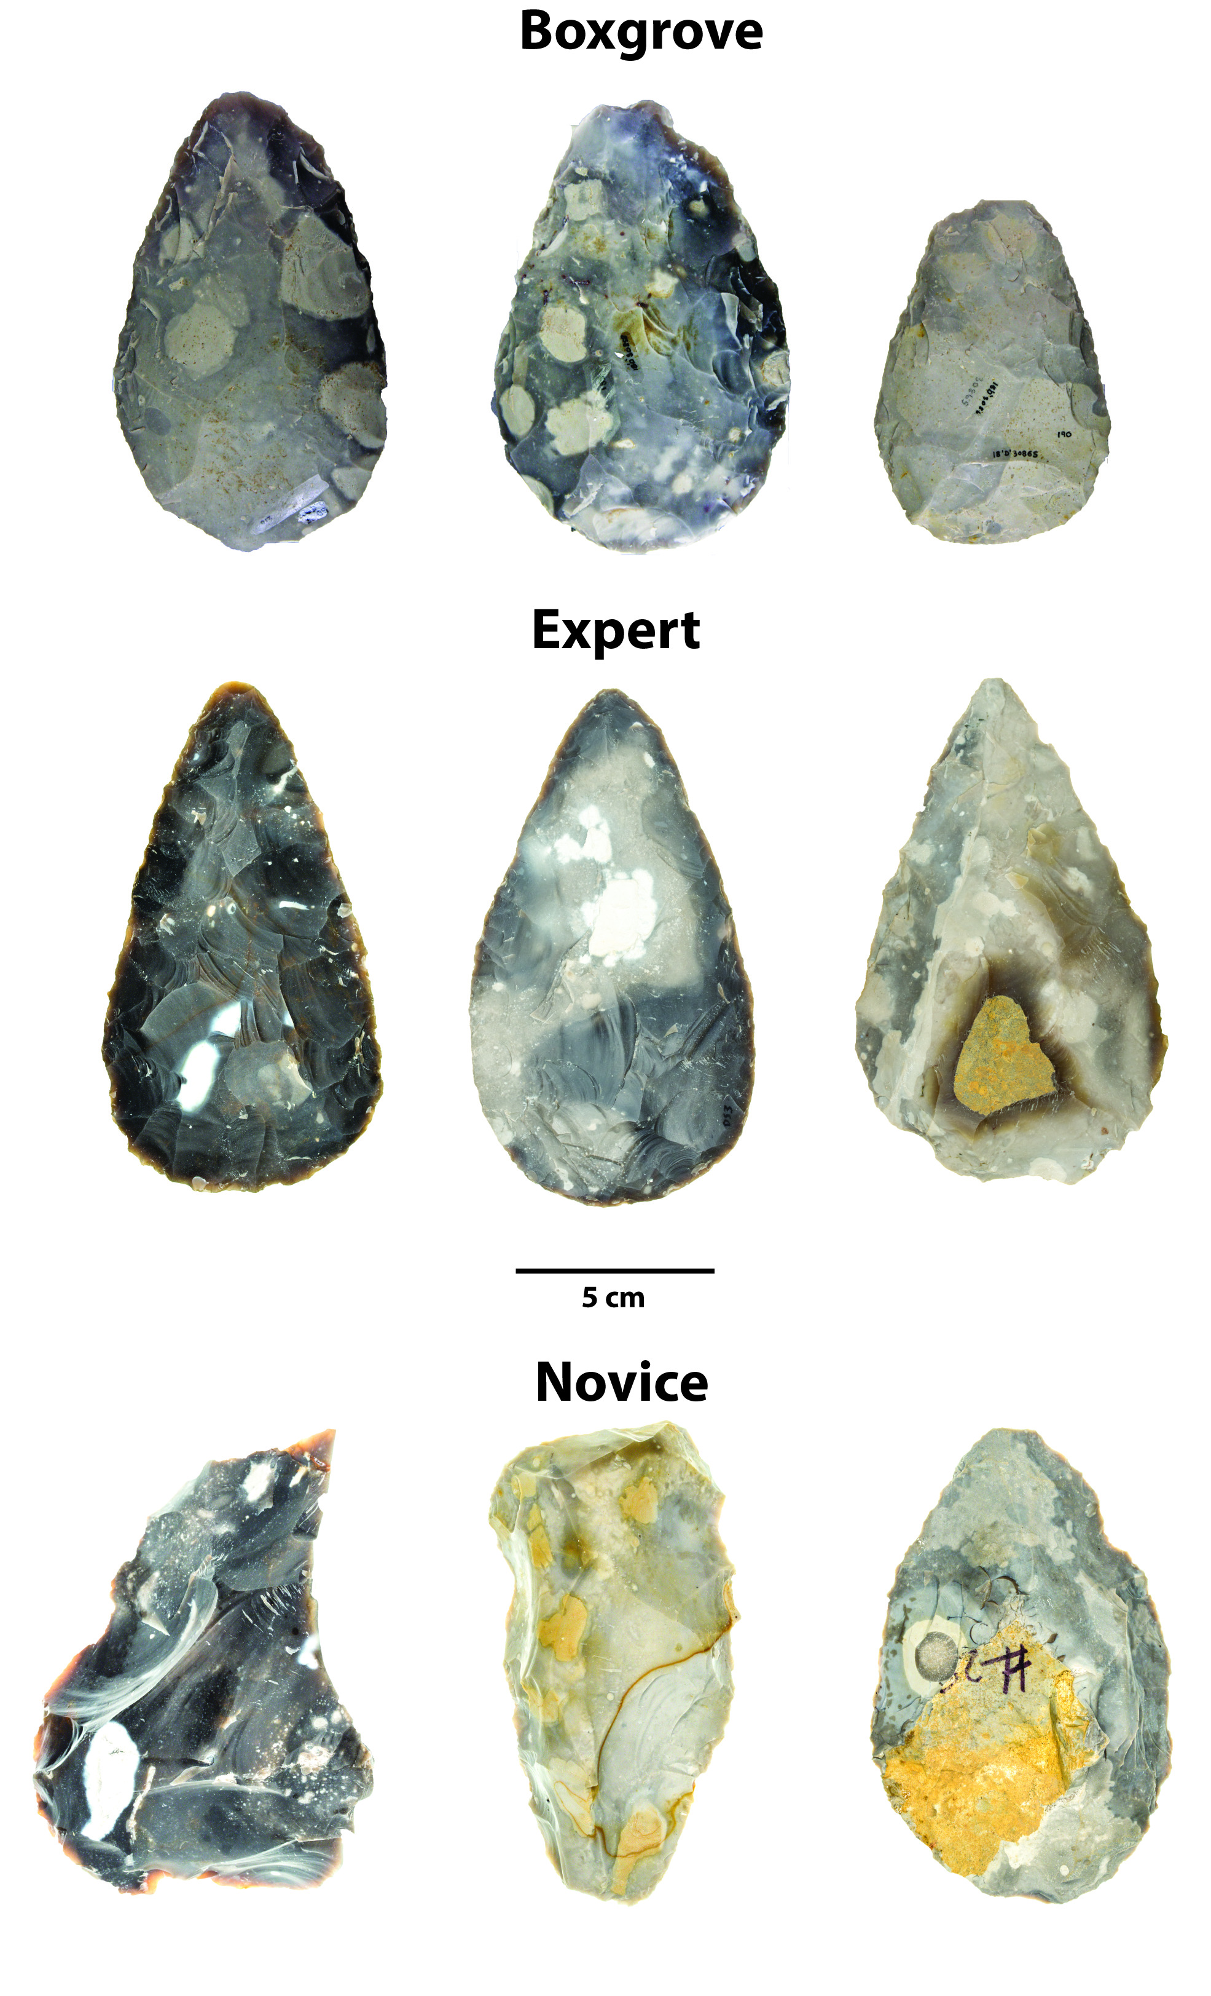

Fig.1. A selection of Boxgrove handaxes and modern replicas produced by experts and novices.

## Experimental handaxe collection

The handaxe experimental replicas used in this study comprised two sub-collection (**Fig. 1**). The first sub-collection includes 10 handaxes knapped by three expert knappers, including Bruce Bradley (n=4), John Lord (n=3), and Dietrich Stout (n=3) (Stout et al., 2014). These handaxes were made for previous research projects, which similarly aimed to approximate ‘Late Acheulean’ handaxes explicitly comparable to the Boxgrove assemblage (Faisal et al., 2010; Stout et al., 2014; Stout et al., 2011). The second sub-collection is produced from a 90-hour handaxe knapping skill acquisition experiment (Bayani et al., 2021; Pargeter et al., 2020; Pargeter et al., 2019), where 30 adults with no previous experience in knapping were recruited from Emory University and its surrounding communities and requested to make 132 handaxes in total. Among these 30 adult participants, 17 have gone through multiple one-to-one or group training sessions that amounted to 89 hours in maximum, while the remaining 13 were assigned to the controlled group, where no formal training is given. As part of the preparation efforts, the experimental team spalled the Norfolk flints acquired through [Neolithics.com](https://neolithics.com/) into flat blanks of similar size and shape for training and assessments. The mechanical properties of these raw materials are comparable to the ones used in Boxgrove in that they are both fine-grained and highly predictable in fracturing process.

In the knapping skill acquisition experiment, all research participants participated in the initial assessment (assessment 1 in our data set) before formal training, where they each produced a handaxe after watching three 15-minute videos of Late Acheulean style handaxes demonstrated by expert knappers and examining four Late Acheulean style handaxe replicas prepared by Bruce Bradley, which are part of our expert sample as described above. Training was provided by verbal instruction and support from the second author, an experienced knapping instructor (Khreisheh et al., 2013), herself trained by Bruce Bradley, with 10 years knapping practice and specific knowledge of Late Acheulean technology including the Boxgrove handaxe assemblage. She was present at all training sessions to provide help and instruction to participants. All training occurred under controlled conditions at the outdoor knapping area of Emory’s Paleolithic Technology Lab, with knapping tools and raw materials provided. All participants were instructed in basic knapping techniques including how to select appropriate percussors, initiate flaking on a nodule, maintain the correct flaking gestures and angles, prepare flake platforms, visualize outcomes, deal with raw material imperfections, and correct mistakes. Handaxe-specific instruction included establishment and maintenance of a bifacial plane, cross-sectional thinning, and overall shaping. The training emphasized both aspects of handaxe making technical skill (the importance of producing thin pieces with centered edges) as well as mental template related markers (symmetrical edges).

Subsequently, the 17 participants in the experimental group were assessed after every ten hours of the cumulative learning period, where each of them was requested to produce a handaxe for instructor’s (N. Khreisheh) review, leading to the compilation of a data set composing 9 assessments in total. It should be also noted that 6 out of 17 participants dropped out of the research before the final assessment due to personal reasons. To understand the effect of skill acquisition on artifact morphology, we reorganized our assessment classification scheme and combined it into three broader categories, namely pre-training (assessment 1), early training (assessment 2-5), and late training (assessment 6-9), which helps increase the sample size of the measured intervals. A more detailed experimental protocol can be assessed in one of our published papers (Pargeter et al., 2019).

## Lithic analysis

To better understand the morphological variation of Boxgrove handaxe collection, we adopted a standardized analytical procedure to extract the morphometric information from 752 photos of the studied samples (Iovita & McPherron, 2011), which include both the front and lateral views of a given specimen. First, we used Adobe Photoshop to conduct a batch transformation of the samples’ pixel scale into a real-world measurement scale based on the fixed photographic setting. This is then followed by the batch conversion of color photographs to a black-and-white binary format. Subsequently, we cropped the silhouettes of handaxes one by one using the Quick Selection Tool in Adobe Photoshop. The metric measurements were conducted in ImageJ (Rueden et al., 2017), where we employed a custom ImageJ script (Pargeter et al., 2019) to measure the maximum length, width, and thickness of a given silhouette. The width and thickness measurements are taken at 10% increments of length starting at the tip of each handaxe (**Fig. 2**), which eventually leads to 19 morphometric variables in total (1 length measurement, 9 width measurements, and 9 thickness measurements). Finally, we calculated the geometric means of all 19 linear measurements to create a scale-free data set that preserves the individual morphological variation at the same time (Lycett et al., 2006). This allometric scaling procedure controls for size variation which may come from initial blanks and/or reduction intensity (shaping/resharpening). Notably, Shipton and Clarkson (2015) previously found that reduction intensity does not have a strong impact on the shape of handaxes. The same procedure was also applied to the morphometric analyses of the experimental handaxe collection, which was partially published in Pargeter et al. (2019).

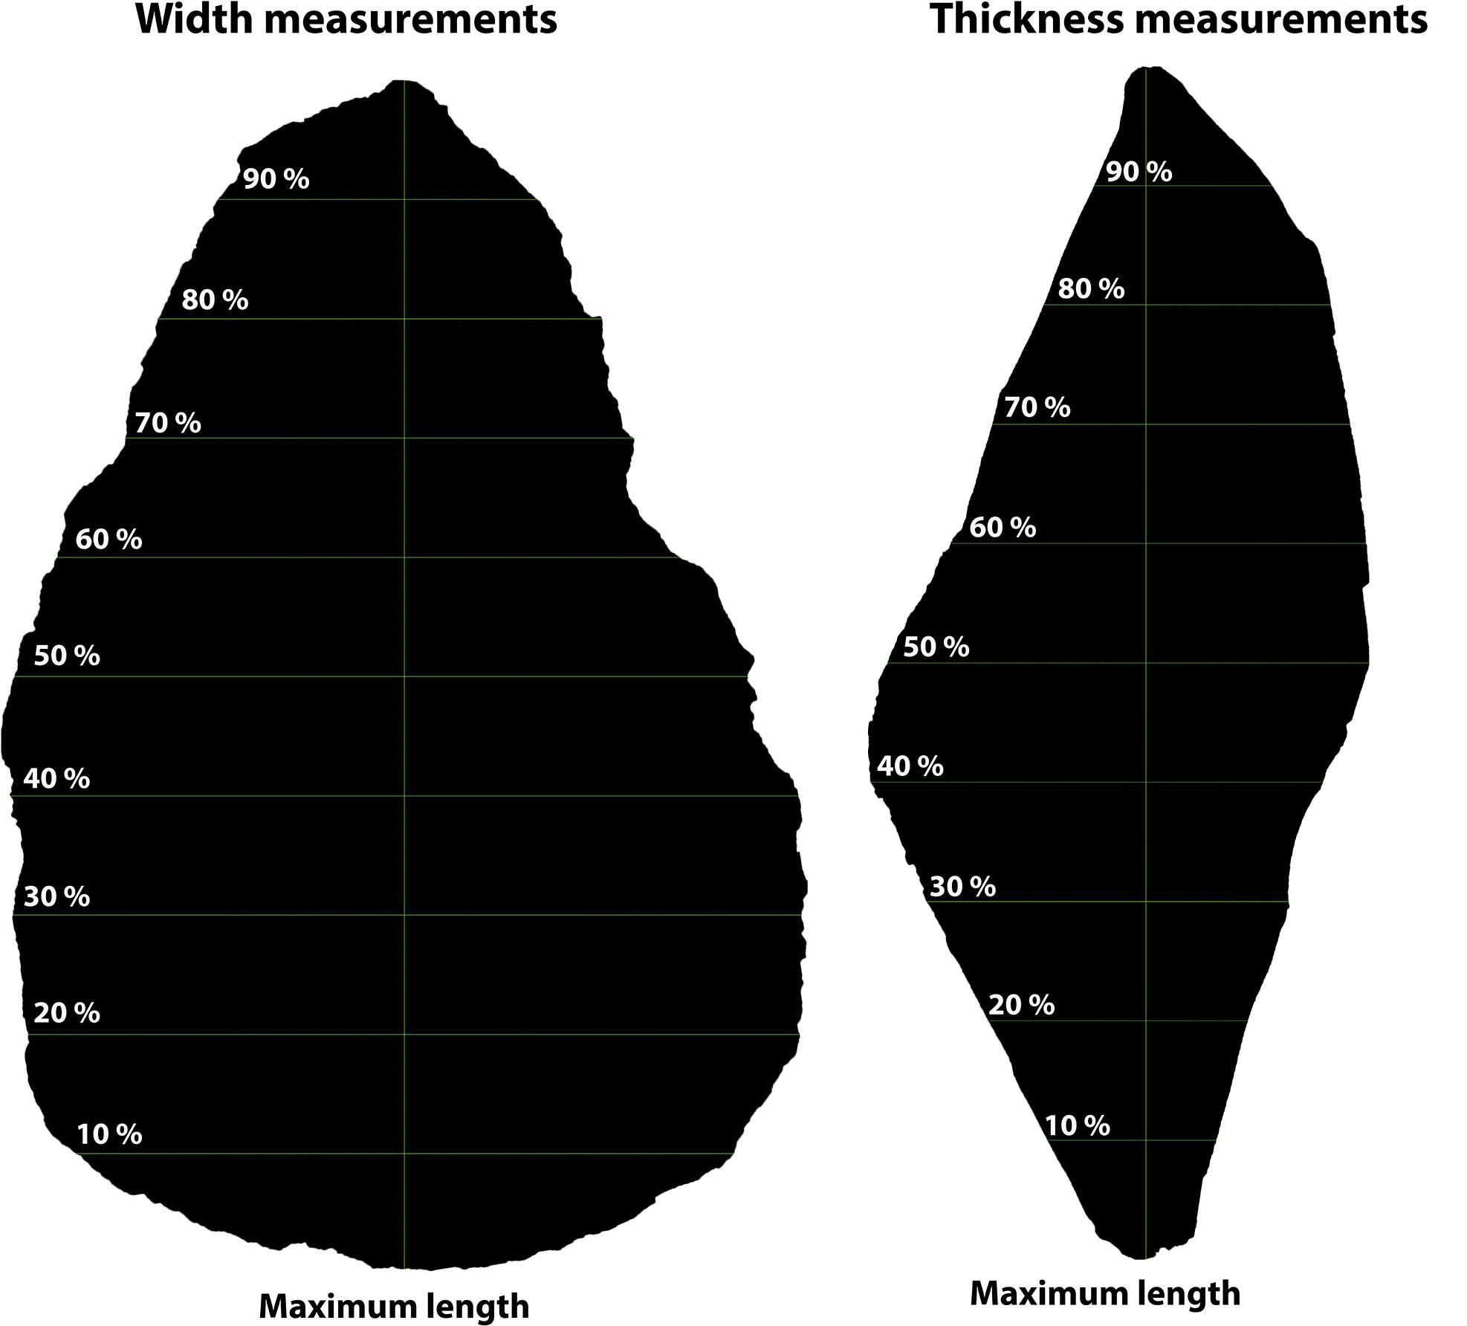

Fig.2. A visual demonstration of the handaxe measurement protocol using Image J (after Pargeter et al. 2019: Figure 5).

## Statistical analyses

We use the statistical programming language R 4.1.1 (R Core Team, 2021) to conduct statistical analyses and data visualization in this study, particularly the R packages “FactoMineR” (Lê et al., 2008) and “ggstatsplot” (Patil, 2021). As the initial step, simple visualization techniques such scatter plots are frequently used to explore the relationships between variables of interest. Given the number of variables involved in this study, we used principal component analysis (PCA) to reduce the dimension and identify the possible patterns in this morphometric data set, which is one of the most used techniques in similar studies (García-Medrano, Maldonado-Garrido, et al., 2020; García-Medrano, Ashton, et al., 2020; Herzlinger et al., 2017; Iovita & McPherron, 2011; Shipton & Clarkson, 2015; Stout et al., 2014). To understand the process of skill learning of novices using the Boxgrove and expert samples as benchmarks, we also compare the corresponding metrics built on PCA across different training periods and across all groups using the Games-Howell nonparametric post-hoc test. Compared with other nonparametric tests frequently used in archaeological research for multiple group comparison such as Tukey’s test, Games-Howell test does not rely on the assumptions of sample normality, and equal sample sizes and equal variance are not necessary conditions to perform this test. The sample size of each compared group can be as low as 6 (Games & Howell, 1976; Sauder & DeMars, 2019), which makes it particularly suitable for this study as the sample size of expert experimental collection is rather small. Lastly, we compare the delta weight, as defined by the difference between initial nodule weight and end product weight, between these groups to understand the effect of reduction intensity on morphological variation. This study adheres to the principles of reproducibility and data transparency of archaeological research by depositing all the codes and data sets involved in an open-access online repository (Marwick, 2017), which are available as supplementary materials and can be accessed through the author’s Github (<https://github.com/Raylc/Boxgrove-Exp>).

# Results

## Principal component analysis

Our analysis suggested that the first two components already explain 77.2% of the variation for the entire morphometric data set composed of 19 variables (**Fig. 3**), which is a rather reasonable variance ratio to avoid overfitting. Variable loadings (**Table** **1**) indicate that the first principal component (PC1) captures relative cross-sectional thickness (“refinement”). It is positively correlated with all thickness measurements while negatively correlated with all other measurements. A higher PC1 value thus indicates a handaxe that is thicker relative to width and length, and vice versa. The second principal component (PC2) tracks elongation and pointedness, as indicated by a positive covariance of maximum length and bottom width/thickness. As PC2 increases, a handaxe will be relatively longer and more convergent from the broad base to the tip. Thus, PC1 corresponds to cross-sectional thinning and PC2 to a narrowing of the tip relative to length and base dimensions.

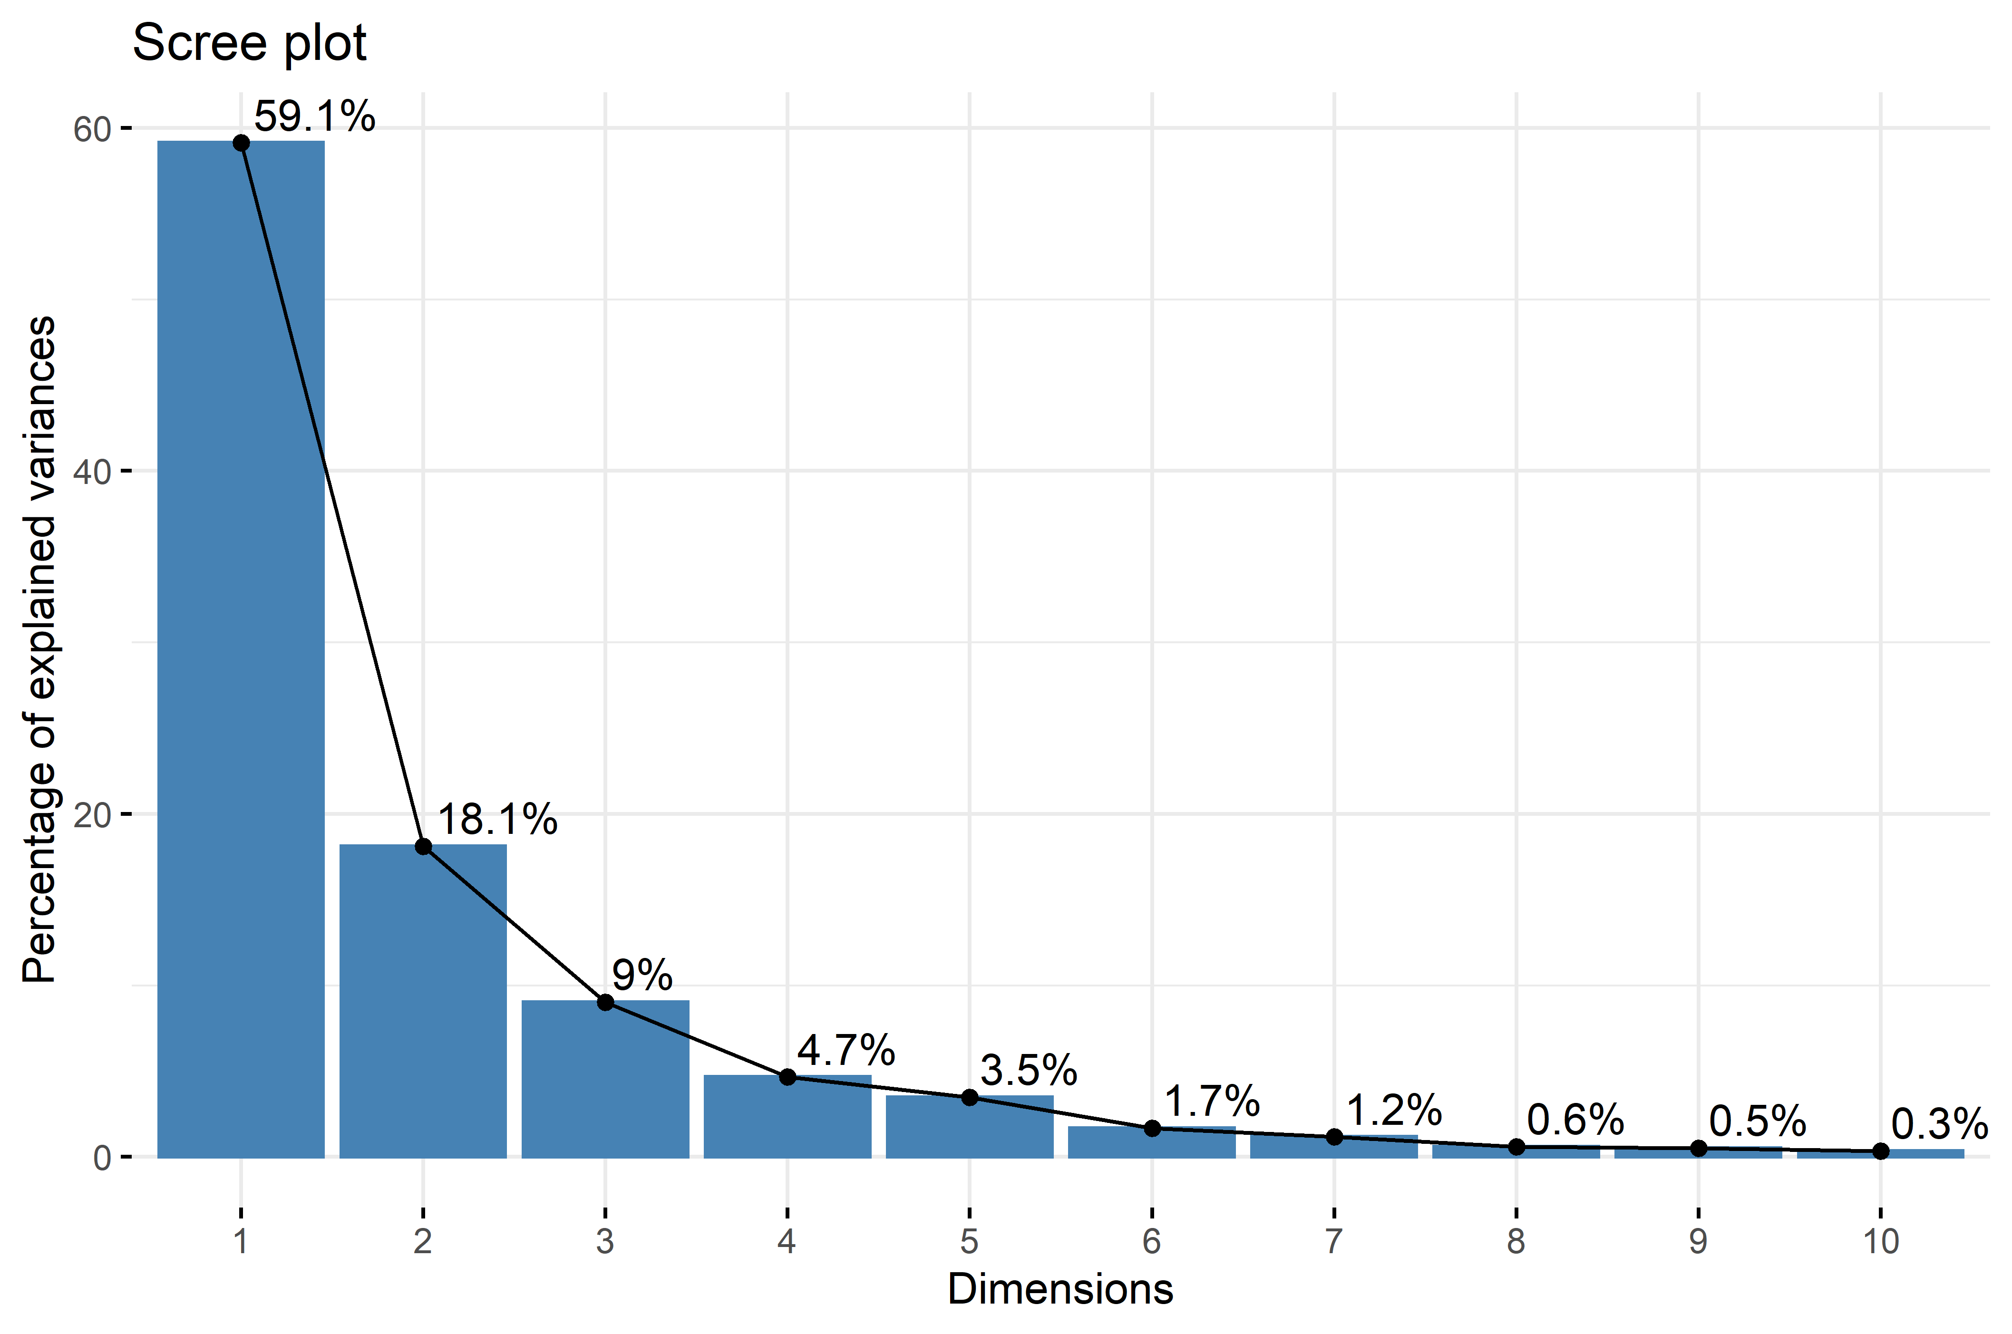

Fig.3. A scree plot showing the percentage of explained variances of the first 10 principal components.

|  |  |  |
| --- | --- | --- |
| **Variables** | **Dim.1** | **Dim.2** |
| width_90% | -0.1131 | -0.1256 |
| width_80% | -0.1420 | -0.1327 |
| width_70% | -0.1684 | -0.1232 |
| width_60% | -0.1867 | -0.0967 |
| width_50% | -0.2037 | -0.0652 |
| width_40% | -0.2121 | -0.0197 |
| width_30% | -0.2083 | **0.0233** |
| width_20% | -0.1886 | **0.0661** |
| width_10% | -0.1447 | **0.0806** |
| thickness_90% | **0.0143** | -0.0240 |
| thickness_80% | **0.0247** | -0.0227 |
| thickness_70% | **0.0436** | -0.0094 |
| thickness_60% | **0.0668** | **0.0048** |
| thickness_50% | **0.0894** | **0.0261** |
| thickness_40% | **0.1083** | **0.0485** |
| thickness_30% | **0.1288** | **0.0629** |
| thickness_20% | **0.1444** | **0.0659** |
| thickness_10% | **0.1309** | **0.0487** |
| max_length | -0.3626 | **0.2507** |

Table 1. Variable loadings for the first two principal components. PC1 (Dim.1) is postively correlated with all thickness-related variables and negatively correlated with all width-related variables and the maximum length. PC2 (Dim.2) is positively with bottom width and thickness variables as well as the miximum length and negatively correlated with width and thickness variables of the tip area.

A closer look at the principal component scatter plot (**Fig. 4**) yields the clustering of different groups of handaxes. The majority of Boxgrove handaxes occupy an area featuring negative values of both PC1 and PC2. The expert group is similar to the Boxgrove group in PC1, while the former has a relatively higher PC2 value than the latter on average. The group of novice displays the highest ranges in both PC1 and PC2 values according to the scatter plot, however, it is rather pronounced that most handaxes made by novices have a positive PC1 value that is different from both the groups of Boxgrove and experts.

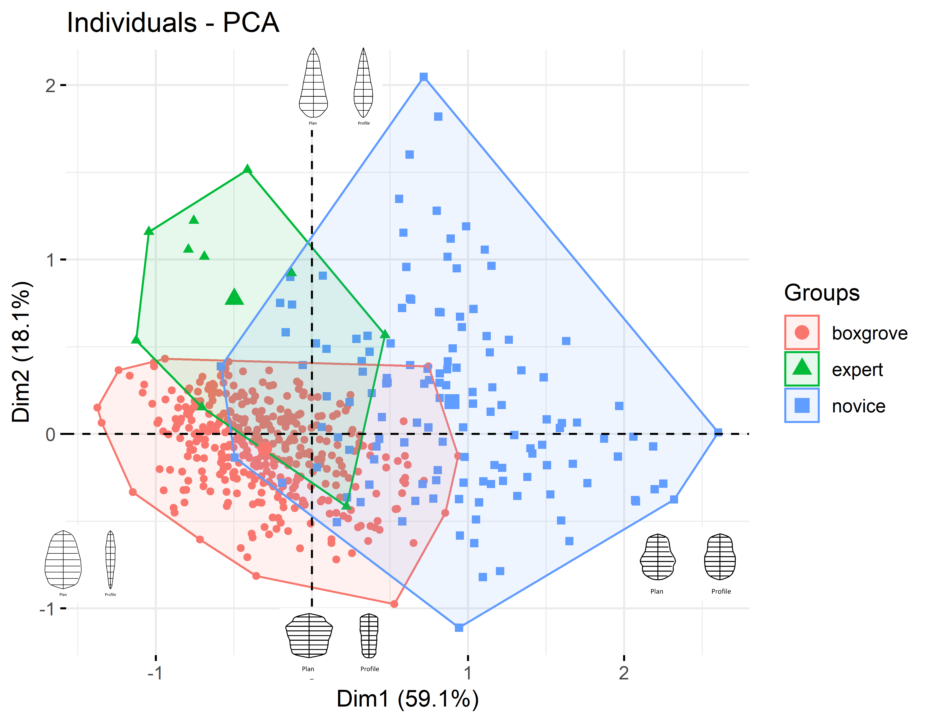

Fig.4. A principal component scatter plot of handaxes from the groups of Boxgrove (red, n=326), expert (green, n=10), and novice (blue, n=132). The four images illustrate simplified plan and profile morphology of handaxes displaying extreme PC values (e.g., The leftmost and uppermost handaxes respectively display the highest PC1 and PC2 value, and vice versa).

In addition, visual inspection of the principle component scatter plot (**Fig. 4**) suggested that PC1 and PC2 might be negatively correlated within the Boxgrove and Expert groups. To test this intuition, we conducted a series of exploratory plotting and statistical analyses of the PC values of three groups analyzed in our analysis (**Fig. 5**). Across all three groups, a negative correlation has been displayed between the PC1 and PC2 values, although this trend is not statistically significant (r=-0.41, p= 0.24) in the expert group, probably because of its small sample size.



Fig.5. A scatter plot showing the correlation between PC1 and PC2 respectively in the groups of Boxgrove (left, n=326), expert (middle, n=10), and novice (right, n=132). The upper left area in each individual plot displays statistical reporting from a frequentist perspective, including the student-t test statistics, p-value, Pearson correlation coefficient, confidence interval, and sample size. The lower right area in each individual plot displays statistical reporting from a Bayesian perspective, including the natural logarithm of Bayes factor, posterior type and estimate, credible interval, and prior type and value.

## Effects of skill acquisition

We extracted the PC1 and PC2 values of individual handaxes and compared them between different groups, where the novice group was divided into three sub-groups based on their training stages as specified in the method section. As such, we found that for PC1 values (**Fig. 6**), the only two group comparisons that are not statistically significant are the one between Boxgrove and Expert ($t=-1.65$, $p>0.05$) and the one between Early training and Late training stages ($t=-0.65$, $p>0.05$), which at least partially confirms our visual observation of the general PCA scatter plot. Likewise, for PC2 values (**Fig. 7**), the group comparison between the Early training and Late stages again is not statistically significant ($t=0.33$, $p>0.05$). Additionally, the pairwise comparisons of mean PC2 values between the Early training and Expert ($t=-3.5$, $p>0.05$) and between the Late training and Expert ($t=-3.68$, $p>0.05$) are also not statistically significant. An unexpected result is that the mean PC2 value difference between the Pre-training group and Boxgrove is also not statistically significant ($t=-0.82$, $p>0.05$). These results essentially suggest that there is a significant difference between the pre-training group and post-training groups in both PC1 (thinning) and PC2 (pointedness), while the effects of training across different assessment periods on both dimensions are not significant. Interestingly, the post-training groups are very different from the expert group in the mean PC1 value, but not in the mean PC2 value. Regarding the delta weight of different groups, our analysis (**Fig. 8**) suggests that there is a significant difference between the pre-training group and Late training group, while all other pairwise group comparison results are insignificant. It can also be inferred that the expert group display a higher variability in terms of delta weight compared with novices.

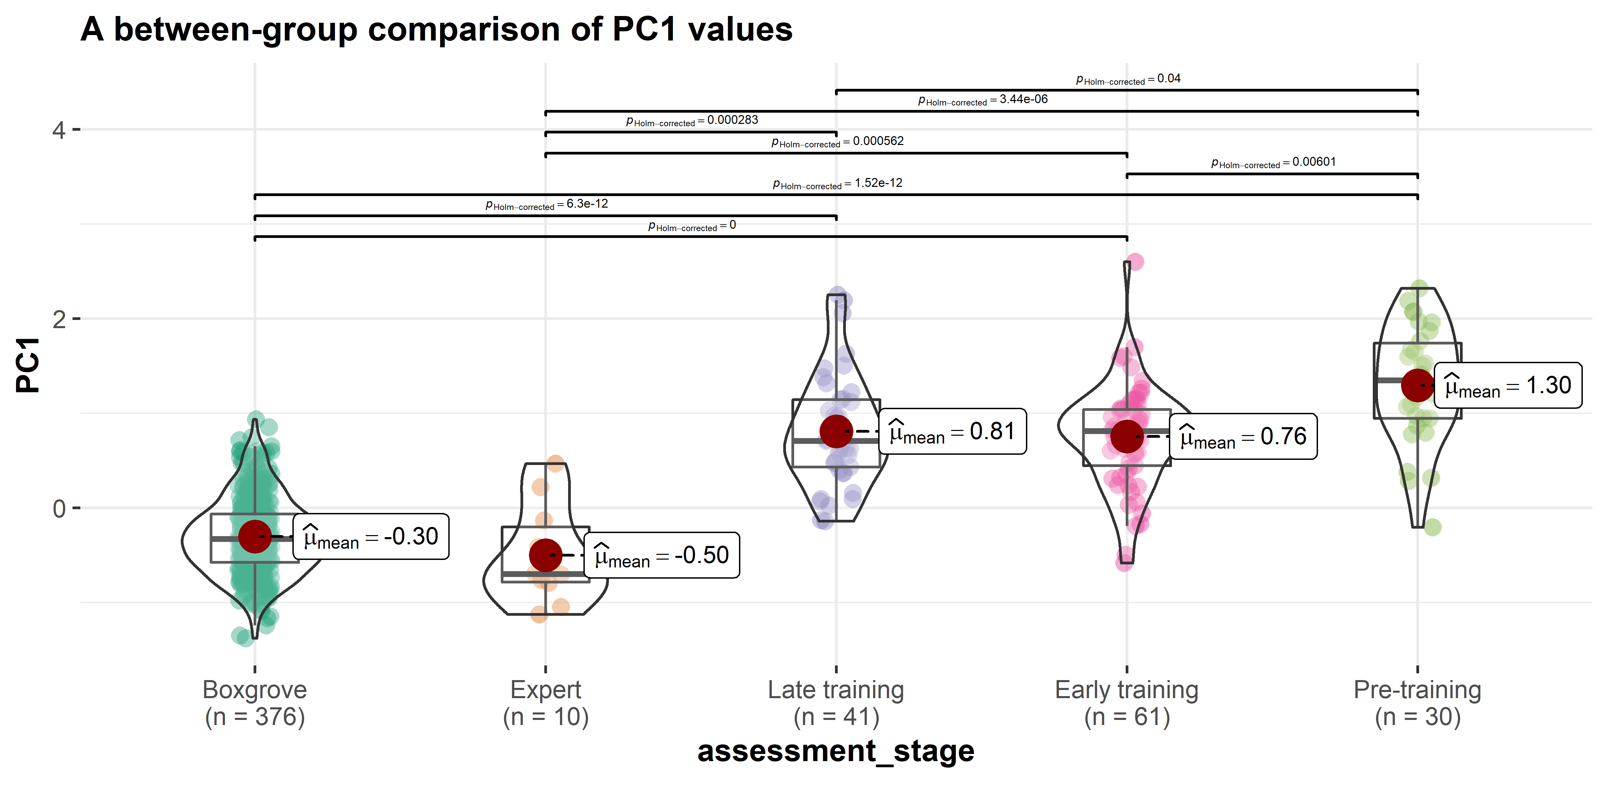

Fig.6. A between-group comparison of PC1 values.

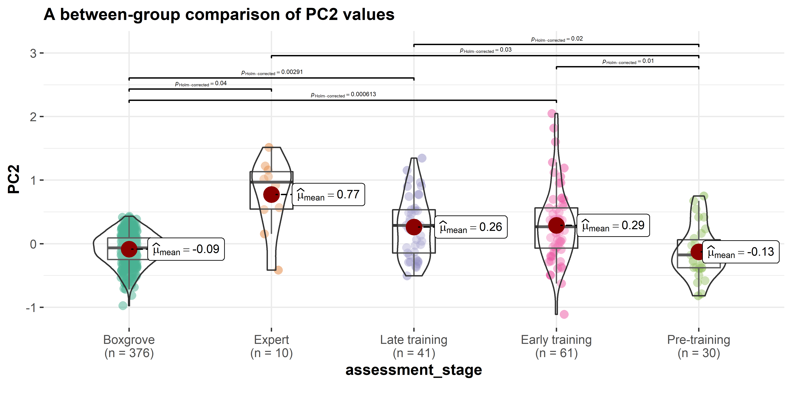

Fig.7. A between-group comparison of PC2 values.

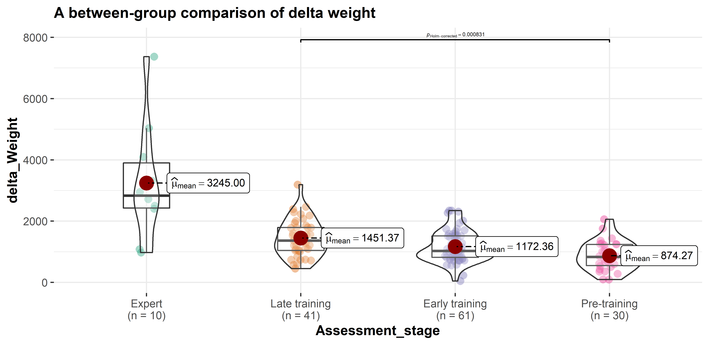

Fig.8. A comparison of the delta weight between the pre-training, early training, late training, and the expert group.

# Discussion

Our study suggests that skill can differentially affect the expression of different aspects of artifact mental templates, potentially biasing processes of cultural reproduction. In the case of handaxe morphology, we found that skill is more highly constraining of cross-sectional thinning (PC1) than it is of handaxe elongation and pointedness (PC2). This is in accordance with the existing literature on handaxe knapping skill (Callahan, 1979; Caruana, 2020; Stout et al., 2014), and supports the use of cross-sectional thinning as a robust indicator of skill at Boxgrove, with potential implications for the cognitive demands and social contexts supporting learning (Pargeter et al., 2019; Stout et al., 2014). It further suggests that cultural evolutionary approaches to handaxe morphology should consider technological choices about investments in skill acquisition (Pargeter et al., 2019) as a directional influence alongside random copy error (Eerkens & Lipo, 2005) as sources of variation. In contrast, we found morphological targets not requiring cross-sectional thinning (elongation and pointedness (PC2)) to be less constrained by skill. These aspects of morphology might thus provide a clearer signal of “arbitrary” cultural variation and accumulating copy error. Notably, Boxgrove handaxes are highly constrained along PC2 compared to our experimental samples, in keeping with prior arguments that production at this site adhered to a well-defined mental template (García-Medrano et al., 2019; Shipton & White, 2020).

Thinning is regarded as a technique requiring a high knapping skill level because it requires one to carefully detach flakes in an invasive manner while not breaking the handaxe into several pieces, serving the purpose of achieving the desired convexity and/or volume. This procedure involves precise control of striking forces, strategic choice of platform external angle, and attentive preparation of bifacial intersection plane, all of which were part of our experimental training program (Callahan, 1979; Caruana, 2022; Pargeter et al., 2020; Shipton et al., 2013; Stout et al., 2014). Experimental studies have also shown that the thinning stage of handaxe produce often involves the use of soft hammers, which is also supported by direct (Bello et al., 2016; Stout et al., 2014) and indirect (Roberts & Parfitt, 1998: 384-394; Roberts & Pope, 2009) archaeological evidence from Boxgrove, although the validity of differentiating percussor types (hard hammerstone, soft hammerstone, and antler hammer) based on flake attributes has been challenged by other experimental studies (Driscoll & García-Rojas, 2014). It should be noted that both our experts and novices frequently used soft hammers in the production of experimental assemblages. In the skill acquisition experiments, novice knappers were explicitly taught to switch to the soft hammer for thinning purposes, although some of them did not follow the instruction during the assessment. On the other hand, it has also been shown that hard hammers can also be used to achieve similar thinning results (Bradley & Sampson, 1986; Pelcin, 1997), and the replicas produced by Bruce Bradley in our expert reference collection did not involve the use of soft hammers.

Unexpectedly, we found that modern experimental knappers did not closely approximate the PC2 (elongation and pointedness) values of Boxgrove handaxes. More specifically, the Boxgrove assemblage displays an ovate shape featuring a wider tip as previously pointed out by Shipton and White (2020) as well as Garcia-Medrano et al. (2019), while the experimental assemblages are characterized by a more pointed shape with a longer central axis (**Fig. 4**). This likely reflects the fact that our expert participants and instructor were verbally requested to make handaxes “comparable to Boxgrove handaxes” (with which they were familiar) but were not provided with a concrete template to copy. It would appear that they thus followed a more generalized archaeological conception of a “representative teardrop Late Acheulean handaxe” with a particular focus on thinning (PC1). This likely also reflects the current cultural value placed on thinning as a marker of skill (Whittaker, 2004: 180-182). Novices sought to approximate this form, as demonstrated by their instructor and exemplar handaxes. In fact, the four examples presented to trainees have a mean PC2 value of 1.18, indicating a high degree of elongation and pointedness. It should be also noted that the instructor (N. Khreisheh) has learned how to knap and how to teach knapping from one of our expert knappers (B. Bradley), potentially suggesting a cascading effect of social learning that also contributed to a shared mental template between the expert group and the novice group after training. At a higher level, this pattern may reflect a divergence of group-level aesthetic choices as expected under the theoretical framework of the communities of practice (Wenger, 1998), which could potentially provide a mechanistic explanation to some macro-level cultural phenomena such as regionalization (Ashton & Davis, 2021; Davis & Ashton, 2019; García-Medrano et al., 2022; Shipton & White, 2020). The most common form of learning in the experiment occurred in the group condition, where the instructor, as the competent group member, directed the joint enterprise by actively teaching multiple novices at the same time. Meanwhile, novices had the chance to also communicate and learn from their peers, producing a shared repertoire of artifacts and actions.

The pre-training group is unexpectedly similar to the Boxgrove group in PC2. This is potentially because these novices lack the ability to effectively reduce the nodules, which are typically flat pre-prepared cortical flakes, to the desired form (**Fig. 9**). If the given nodules already possess an oval morphology like those presented in the Boxgrove assemblage, it is likely the form of end products knapped by novices in the pre-training group will remain roughly unchanged (Winton, 2005: 113). This explanation is also supported by the comparison of average delta weight, defined as the difference between the weight of a handaxe and the weight of its corresponding nodule, among four groups, where the pre-training group displays the lowest value (**Fig. 8**). It might be worth noting that the expert group is highly variable probably due to the raw material starting size and/or shape. Achieving handaxe forms while removing as little mass as possible (i.e. making as big a handaxe as possible from the nodule) generally requires a higher skill level due to the reductive or subtractive nature of stone knapping, where correcting an error or any thinning procedure always requires the removal of raw material and thereby reducing the size of a given handaxe (Schillinger et al., 2014b: 130; Deetz, 1967: 48-49). On the other hand, the refitting analyses of the Boxgrove handaxe assemblage have suggested that the nodules exploited by knappers inhabiting this site are somewhat bulky and amorphous (Roberts & Parfitt, 1998: 339, 360). These characteristics have been clearly displayed in a recent attempt of slow-motion refitting of a handaxe specimen from Boxgrove GTP17 (<https://www.youtube.com/watch?v=iS58MUJ1ZEo>). As such, we infer that behind the resemblance of the pre-training group and the Boxgrove assemblage in PC2 are two types of mechanisms that are fundamentally different from each other, where the latter group exhibits a complex suite of cognitive and motor execution processes to transform the shapeless raw materials to a delicate end product in a given shape.

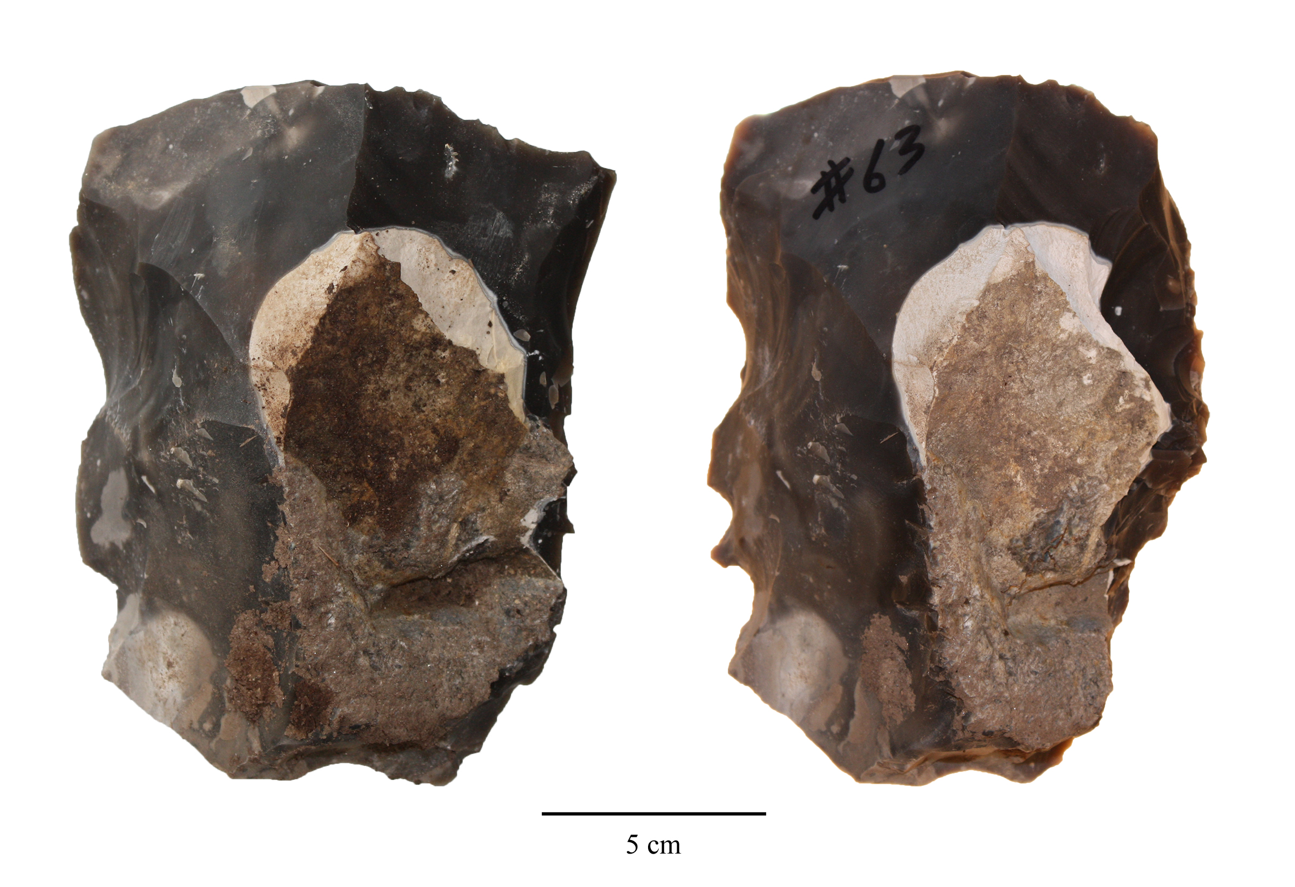

Fig.9. Core 63 before (left) and after knapping(right), showing the minimal morphological change during the knapping process.

The negative correlation between the PC1 and PC2 values suggests a hidden structural constraint regarding the relationship between cross-sectional thinning and the imposed form. Our results (**Fig. 5**) suggested thinner handaxes (low PC1 value) are generally more pointed/less ovate (high PC2 value), which was first reported in Crompton and Gowlett’s (1993) pioneering study on the allometry of Kilombe handaxes. In the thinning phase of handaxe making, a knapper must strike flakes that travel more than half way across the surface while not breaking the handaxe into half (1979: 90). As a corollary, we speculate that it would be easier to perform thinning if the plan shape of a handaxe is narrower and more pointed, echoing the high technological difficulty of making large yet thin bifacial points as perceived by American hobbyist flintknappers (Whittaker, 2004: 180-182). It is possible that such constraints help to explain why our novice knappers on average produced more handaxes in similar shapes to those preferred by modern expert knappers, however, this clearly does not explain the design target at Boxgrove. Given the ovate forms of the Boxgrove assemblage, it thus requires a high skill level to overcome this structural constraint to produce thin yet wide handaxes as demonstrated by the Boxgrove knappers. This also provides an alternative explanation to the cultural reproduction of form for the experimental convergence on pointed forms. In this comparative context, it would only be the Boxgrove assemblage that provided evidence of social conformity on a more difficult target shape.

As previously shown in Key’s (2019) previous finding regarding Boxgrove, it is also noteworthy how constrained the range of Boxgrove assemblage morphological variation is as measured by both PC1 and PC2 even when compared with the modern expert group (**Fig. 4**), especially given the fact that it has the largest sample size among all studied groups. Some potential explanations for this phenomenon include 1) the strong idiosyncrasy of individual expert knappers shaped by their own unique learning and practice experience; 2) the present-day skill shortage of our expert knapper as compared with Boxgrove knappers despite their multiple years of knapping practice (Milks, 2019); and/or 3) modern knappers’ skill level was affected by time constraints when they were requested to produce the reference collections (Lewis et al., 2022; Schillinger et al., 2014c).

# Conclusion

Our case study suggested that the processes of skill learning in a lithic medium does in fact exert biases on the cultural reproduction of artifact morphology. More specifically, skill acquisition has a differential effect on the cultural reproduction of different aspects of mental templates, where cross-sectional thinning (PC1) is more constrained by knapping skill while elongation and pointedness (PC2) is less so. At a larger theoretical level, these results question the distinction between social learning of design targets vs. individual learning of the skills needed to achieve them. In the future, more robust experimental studies are needed to deepen our understanding of the relationship between skill acquisition and the morphological variability of handaxes in the proper developmental context (Högberg, 2018; Lew-Levy et al., 2020; Nowell, 2021) as well as their implications for the biological and cultural evolution of the hominin lineages.

# CRediT authorship contribution statement

**Cheng Liu**: Conceptualization, Data curation, Formal analysis, Investigation, Methodology, Visualization, Writing – original draft, Writing – review & editing. **Nada Khreisheh**: Investigation, Writing – review & editing. **Dietrich Stout**: Conceptualization, Investigation, Resources, Funding acquisition, Supervision, Writing – original draft, Writing – review & editing. **Justin Pargeter**: Conceptualization, Investigation, Methodology, Supervision, Writing – original draft, Writing – review & editing.

# Declaration of competing interest

The authors declare that they have no known competing financial interests or personal relationships that could have appeared to influence the work reported in this paper.

# Acknowledgements

We would like to thank Thomas Jennings and three other anonymous reviewers for their insightful feedback on an earlier draft of this manuscript. This work was supported by funding from the National Science Foundation of the USA (grants SMA-1328567 & DRL-1631563), the John Templeton Foundation (grant 47994), and the Emory University Research Council. The handaxe knapping skill acquisition experiment involved in this study was approved by Emory University’s Internal Review Board (IRB study no: 00067237). We would also like to thank Radu Iovita for providing us access to the digital photographs of the Boxgrove handaxe assemblage.

# References

Ashton, N., & Davis, R. (2021). Cultural mosaics, social structure, and identity: The Acheulean threshold in Europe. *Journal of Human Evolution*, *156*, 103011. <https://doi.org/10.1016/j.jhevol.2021.103011>

Bamforth, D. B., & Finlay, N. (2008). Introduction: Archaeological approaches to lithic production skill and craft learning. *Journal of Archaeological Method and Theory*, *15*(1), 1–27. <https://www.jstor.org/stable/40345992>

Bayani, K. Y. T., Natraj, N., Khresdish, N., Pargeter, J., Stout, D., & Wheaton, L. A. (2021). Emergence of perceptuomotor relationships during paleolithic stone toolmaking learning: intersections of observation and practice. *Communications Biology*, *4*(1), 1–12. <https://doi.org/10.1038/s42003-021-02768-w>

Bello, S. M., Delbarre, G., De Groote, I., & Parfitt, S. A. (2016). A newly discovered antler flint-knapping hammer and the question of their rarity in the Palaeolithic archaeological record: Reality or bias? *Quaternary International*, *403*, 107–117. <https://doi.org/10.1016/j.quaint.2015.11.094>

Bello, S. M., Parfitt, S. A., & Stringer, C. (2009). Quantitative micromorphological analyses of cut marks produced by ancient and modern handaxes. *Journal of Archaeological Science*, *36*(9), 1869–1880. <https://doi.org/10.1016/j.jas.2009.04.014>

Bradley, B. A., & Sampson, C. G. (1986). *Analysis by replication of two acheuleian artefact assemblages from caddington, england* (G. Bailey & P. Callow, Eds.; pp. 29–46). Cambridge University Press.

Callahan, E. (1979). The basics of biface knapping in the eastern fluted point tradition: A manual for flintknappers and lithic analysts. *Archaeology of Eastern North America*, *7*(1), 1–180. <https://www.jstor.org/stable/40914177>

Caruana, M. V. (2022). Extrapolating later acheulian handaxe reduction sequences in south africa: A case study from the cave of hearths and amanzi springs. *Lithic Technology*, *47*(1), 1–12. <https://doi.org/10.1080/01977261.2021.1924452>

Caruana, M. V. (2020). South African handaxes reloaded. *Journal of Archaeological Science: Reports*, *34*, 102649. <https://doi.org/10.1016/j.jasrep.2020.102649>

Caruana, M. V., & Herries, A. I. R. (2021). Modelling production mishaps in later Acheulian handaxes from the Area 1 excavation at Amanzi Springs (Eastern Cape, South Africa) and their effects on reduction and morphology. *Journal of Archaeological Science: Reports*, *39*, 103121. <https://doi.org/10.1016/j.jasrep.2021.103121>

Charbonneau, M., & Strachan, J. W. A. (2022). From Copying to Coordination: An Alternative Framework for Understanding Cultural Learning Mechanisms. *Journal of Cognition and Culture*, *22*(5), 451–466. <https://doi.org/10.1163/15685373-12340145>

Clark, J. D. (2001). *Variability in primary and secondary technologies of the later acheulian in africa* (S. Milliken & J. Cook, Eds.; p. 118). Oxbow Books.

Connolly, K., & Dalgleish, M. (1989). The emergence of a tool-using skill in infancy. *Developmental Psychology*, *25*(6), 894–912. <https://doi.org/10.1037/0012-1649.25.6.894>

Corbey, R. (2020). Baldwin effects in early stone tools. *Evolutionary Anthropology: Issues, News, and Reviews*, *29*(5), 237–244. <https://doi.org/10.1002/evan.21864>

Corbey, R., Jagich, A., Vaesen, K., & Collard, M. (2016). The acheulean handaxe: More like a bird’s song than a beatles’ tune? *Evolutionary Anthropology: Issues, News, and Reviews*, *25*(1), 6–19. <https://doi.org/10.1002/evan.21467>

Crompton, R. H., & Gowlett, J. A. J. (1993). Allometry and multidimensional form in Acheulean bifaces from Kilombe, Kenya. *Journal of Human Evolution*, *25*(3), 175–199. <https://doi.org/10.1006/jhev.1993.1043>

Davis, R., & Ashton, N. (2019). Landscapes, environments and societies: The development of culture in Lower Palaeolithic Europe. *Journal of Anthropological Archaeology*, *56*, 101107. <https://doi.org/10.1016/j.jaa.2019.101107>

Deetz, J. (1967). *Invitation to archaeology*. Natural History Press.

Driscoll, K., & García-Rojas, M. (2014). Their lips are sealed: identifying hard stone, soft stone, and antler hammer direct percussion in Palaeolithic prismatic blade production. *Journal of Archaeological Science*, *47*, 134–141. <https://doi.org/10.1016/j.jas.2014.04.008>

Eerkens, J. W., & Lipo, C. P. (2005). Cultural transmission, copying errors, and the generation of variation in material culture and the archaeological record. *Journal of Anthropological Archaeology*, *24*(4), 316–334. <https://doi.org/10.1016/j.jaa.2005.08.001>

Eerkens, J. W., & Lipo, C. P. (2007). Cultural transmission theory and the archaeological record: Providing context to understanding variation and temporal changes in material culture. *Journal of Archaeological Research*, *15*(3), 239274. https://doi.org/<https://doi.org/10.1007/s10814-007-9013-z>

Eren, M. I., Roos, C. I., Story, B. A., von Cramon-Taubadel, N., & Lycett, S. J. (2014). The role of raw material differences in stone tool shape variation: an experimental assessment. *Journal of Archaeological Science*, *49*, 472–487. <https://doi.org/10.1016/j.jas.2014.05.034>

Faisal, A., Stout, D., Apel, J., & Bradley, B. (2010). The Manipulative Complexity of Lower Paleolithic Stone Toolmaking. *PLOS ONE*, *5*(11), e13718. <https://doi.org/10.1371/journal.pone.0013718>

Games, P. A., & Howell, J. F. (1976). Pairwise multiple comparison procedures with unequal n’s and/or variances: A monte carlo study. *Journal of Educational Statistics*, *1*(2), 113–125. <https://doi.org/10.2307/1164979>

García-Medrano, P., Ashton, N., Moncel, M.-H., & Ollé, A. (2020). The WEAP method: A new age in the analysis of the Acheulean handaxess. *Journal of Paleolithic Archaeology*, *3*(4). <https://doi.org/10.1007/s41982-020-00054-5>

García-Medrano, P., Maldonado-Garrido, E., Ashton, N., & Ollé, A. (2020). Objectifying processes: The use of geometric morphometrics and multivariate analyses on Acheulean tools. *Journal of Lithic Studies*, *7*(1). <https://doi.org/10.2218/jls.4327>

García-Medrano, P., Ollé, A., Ashton, N., & Roberts, M. B. (2019). The Mental Template in Handaxe Manufacture: New Insights into Acheulean Lithic Technological Behavior at Boxgrove, Sussex, UK. *Journal of Archaeological Method and Theory*, *26*(1), 396–422. <https://doi.org/10.1007/s10816-018-9376-0>

García-Medrano, P., Shipton, C., White, M., & Ashton, N. (2022). Acheulean diversity in britain (MIS 15-MIS11): From the standardization to the regionalization of technology. *Frontiers in Earth Science*, *10*. <https://www.frontiersin.org/articles/10.3389/feart.2022.917207>

Gowlett, J. A. J. (2021). Deep structure in the Acheulean adaptation: technology, sociality and aesthetic emergence. *Adaptive Behavior*, *29*(2), 197–216. <https://doi.org/10.1177/1059712320965713>

Gowlett, J. A. J. (2006). *The elements of design form in acheulian bifaces: Modes, modalities, rules and language* (N. Goren-Inbar & G. Sharon, Eds.; pp. 203–222). Equinox.

Henrich, J. (2015). *The Secret of Our Success: How Culture Is Driving Human Evolution, Domesticating Our Species, and Making Us Smarter*. Princeton University Press.

Herzlinger, G., Goren-Inbar, N., & Grosman, L. (2017). A new method for 3D geometric morphometric shape analysis: The case study of handaxe knapping skill. *Journal of Archaeological Science: Reports*, *14*, 163–173. <https://doi.org/10.1016/j.jasrep.2017.05.013>

Hillson, S. W., Parfitt, S. A., Bello, S. M., Roberts, M. B., & Stringer, C. B. (2010). Two hominin incisor teeth from the middle Pleistocene site of Boxgrove, Sussex, England. *Journal of Human Evolution*, *59*(5), 493–503. <https://doi.org/10.1016/j.jhevol.2010.06.004>

Hodgson, D. (2015). The symmetry of Acheulean handaxes and cognitive evolution. *Journal of Archaeological Science: Reports*, *2*, 204–208. <https://doi.org/10.1016/j.jasrep.2015.02.002>

Högberg, A. (2018). Approaches to children’s knapping in lithic technology studies. *Revista de Arqueologia*, *31*(2), 58–74. <https://doi.org/10.24885/sab.v31i2.613>

Holmes, J. A., Atkinson, T., Fiona Darbyshire, D. P., Horne, D. J., Joordens, J., Roberts, M. B., Sinka, K. J., & Whittaker, J. E. (2010). Middle Pleistocene climate and hydrological environment at the Boxgrove hominin site (West Sussex, UK) from ostracod records. *Quaternary Science Reviews*, *29*(13), 1515–1527. <https://doi.org/10.1016/j.quascirev.2009.02.024>

Hutchence, L., & Debackere, S. (2019). An evaluation of behaviours considered indicative of skill in handaxe manufacture. *LithicsThe Journal of the Lithic Studies Society*, *39*, 36.

Hutchence, L., & Scott, C. (2021). Is Acheulean Handaxe Shape the Result of Imposed ‘Mental Templates’ or Emergent in Manufacture? Dissolving the Dichotomy through Exploring ‘Communities of Practice’ at Boxgrove, UK. *Cambridge Archaeological Journal*, *31*(4), 675–686. <https://doi.org/10.1017/S0959774321000251>

Iovita, R., & McPherron, S. P. (2011). The handaxe reloaded: A morphometric reassessment of Acheulian and Middle Paleolithic handaxes. *Journal of Human Evolution*, *61*(1), 61–74. <https://doi.org/10.1016/j.jhevol.2011.02.007>

Iovita, R., Tuvi-Arad, I., Moncel, M.-H., Despriée, J., Voinchet, P., & Bahain, J.-J. (2017). High handaxe symmetry at the beginning of the European Acheulian: The data from la Noira (France) in context. *PLOS ONE*, *12*(5), e0177063. <https://doi.org/10.1371/journal.pone.0177063>

Isaac, G. L. (1986). *Foundation stones: Early artefacts as indicators of activities and abilities* (G. Bailey & P. Callow, Eds.; pp. 221–241). Cambridge University Press.

Kempe, M., Lycett, S., & Mesoudi, A. (2012). An experimental test of the accumulated copying error model of cultural mutation for Acheulean handaxe size. *PLOS ONE*, *7*(11), e48333. <https://doi.org/10.1371/journal.pone.0048333>

Key, A. J. M. (2019). Handaxe shape variation in a relative context. *Comptes Rendus Palevol*, *18*(5), 555–567. <https://doi.org/10.1016/j.crpv.2019.04.008>

Key, A. J. M., & Lycett, S. J. (2017). Influence of Handaxe Size and Shape on Cutting Efficiency: A Large-Scale Experiment and Morphometric Analysis. *Journal of Archaeological Method and Theory*, *24*(2), 514–541. <https://doi.org/10.1007/s10816-016-9276-0>

Key, A. J. M., & Lycett, S. J. (2019). Biometric variables predict stone tool functional performance more effectively than tool-form attributes: a case study in handaxe loading capabilities. *Archaeometry*, *61*(3), 539–555. <https://doi.org/10.1111/arcm.12439>

Key, A. J. M., Proffitt, T., Stefani, E., & Lycett, S. J. (2016). Looking at handaxes from another angle: Assessing the ergonomic and functional importance of edge form in Acheulean bifaces. *Journal of Anthropological Archaeology*, *44*, 43–55. <https://doi.org/10.1016/j.jaa.2016.08.002>

Khreisheh, N. N., Davies, D., & Bradley, B. A. (2013). Extending Experimental Control: The Use of Porcelain in Flaked Stone Experimentation. *Advances in Archaeological Practice*, *1*(1), 38–46. <https://doi.org/10.7183/2326-3768.1.1.37>

Kohn, M., & Mithen, S. (1999). Handaxes: products of sexual selection? *Antiquity*, *73*(281), 518–526. <https://doi.org/10.1017/S0003598X00065078>

Kolhatkar, M. (2022). Skill in Stone Knapping: an Ecological Approach. *Journal of Archaeological Method and Theory*, *29*(1), 251–304. <https://doi.org/10.1007/s10816-021-09521-x>

Kuhn, S. L. (2020). *The Evolution of Paleolithic Technologies*. Routledge.

Laland, K. N., Uller, T., Feldman, M. W., Sterelny, K., Müller, G. B., Moczek, A., Jablonka, E., & Odling-Smee, J. (2015). The extended evolutionary synthesis: Its structure, assumptions and predictions. *Proceedings of the Royal Society B: Biological Sciences*, *282*(1813), 20151019. <https://doi.org/10.1098/rspb.2015.1019>

Le Tensorer, J.-M. (2006). Les cultures acheuléennes et la question de l’émergence de la pensée symbolique chez Homo erectus à partir des données relatives à la forme symétrique et harmonique des bifaces. *Comptes Rendus Palevol*, *5*(1), 127–135. <https://doi.org/10.1016/j.crpv.2005.12.003>

Lê, S., Josse, J., & Husson, F. (2008). FactoMineR: An R Package for Multivariate Analysis. *Journal of Statistical Software*, *25*, 1–18. <https://doi.org/10.18637/jss.v025.i01>

Lewis, A. R., Williams, J. C., Buchanan, B., Walker, R. S., Eren, M. I., & Bebber, M. R. (2022). Knapping quality of local versus exotic Upper Mercer chert (Ohio, USA) during the Holocene. *Geoarchaeology*, *37*(3), 486–496. <https://doi.org/10.1002/gea.21904>

Lew-Levy, S., Milks, A., Lavi, N., Pope, S. M., & Friesem, D. E. (2020). Where innovations flourish: An ethnographic and archaeological overview of huntergatherer learning contexts. *Evolutionary Human Sciences*, *2*, e31. <https://doi.org/10.1017/ehs.2020.35>

Liu, C., & Stout, D. (2022). Inferring cultural reproduction from lithic data: A critical review. *Evolutionary anthropology*. <https://doi.org/10.1002/evan.21964>

Lockey, A. L., Rodríguez, L., Martín-Francés, L., Arsuaga, J. L., Bermúdez de Castro, J. M., Crété, L., Martinón-Torres, M., Parfitt, S., Pope, M., & Stringer, C. (2022). Comparing the Boxgrove and Atapuerca (Sima de los Huesos) human fossils: Do they represent distinct paleodemes? *Journal of Human Evolution*, *172*, 103253. <https://doi.org/10.1016/j.jhevol.2022.103253>

Lycett, S. J., & Cramon-Taubadel, N. von. (2015). Toward a “Quantitative Genetic” Approach to Lithic Variation. *Journal of Archaeological Method and Theory*, *22*(2), 646–675. <https://doi.org/10.1007/s10816-013-9200-9>

Lycett, S. J., & Gowlett, J. A. J. (2008). On questions surrounding the acheulean ’tradition’. *World Archaeology*, *40*(3), 295–315. <https://www.jstor.org/stable/40388215>

Lycett, S. J., Schillinger, K., Eren, M. I., von Cramon-Taubadel, N., & Mesoudi, A. (2016). Factors affecting Acheulean handaxe variation: Experimental insights, microevolutionary processes, and macroevolutionary outcomes. *Quaternary International*, *411*, 386–401. <https://doi.org/10.1016/j.quaint.2015.08.021>

Lycett, S. J., von Cramon-Taubadel, N., & Foley, R. A. (2006). A crossbeam co-ordinate caliper for the morphometric analysis of lithic nuclei: a description, test and empirical examples of application. *Journal of Archaeological Science*, *33*(6), 847–861. <https://doi.org/10.1016/j.jas.2005.10.014>

Lyman, R. L., & O’Brien, M. J. (2004). A History of Normative Theory in Americanist Archaeology. *Journal of Archaeological Method and Theory*, *11*(4), 369–396. <https://doi.org/10.1007/s10816-004-1420-6>

Machin, A. J., Hosfield, R. T., & Mithen, S. J. (2007). Why are some handaxes symmetrical? Testing the influence of handaxe morphology on butchery effectiveness. *Journal of Archaeological Science*, *34*(6), 883–893. <https://doi.org/10.1016/j.jas.2006.09.008>

Marwick, B. (2017). Computational Reproducibility in Archaeological Research: Basic Principles and a Case Study of Their Implementation. *Journal of Archaeological Method and Theory*, *24*(2), 424–450. <https://doi.org/10.1007/s10816-015-9272-9>

McNabb, J., Binyon, F., & Hazelwood, L. (2004). The large cutting tools from the south african acheulean and the question of social traditions. *Current Anthropology*, *45*(5), 653–677. <https://doi.org/10.1086/423973>

McNabb, J., & Cole, J. (2015). The mirror cracked: Symmetry and refinement in the Acheulean handaxe. *Journal of Archaeological Science: Reports*, *3*, 100–111. <https://doi.org/10.1016/j.jasrep.2015.06.004>

Milks, A. (2019). Skills shortage: a critical evaluation of the use of human participants in early spear experiments. *EXARC Journal*, *2019*(2), 1–11. <https://pdf.printfriendly.com/pdfs/make>

Moncel, M.-H., Arzarello, M., Boëda, É., Bonilauri, S., Chevrier, B., Gaillard, C., Forestier, H., Yinghua, L., Sémah, F., & Zeitoun, V. (2018a). Assemblages with bifacial tools in Eurasia (third part). Considerations on the bifacial phenomenon throughout Eurasia. *Comptes Rendus Palevol*, *17*(1), 77–97. <https://doi.org/10.1016/j.crpv.2015.11.007>

Moncel, M.-H., Arzarello, M., Boëda, É., Bonilauri, S., Chevrier, B., Gaillard, C., Forestier, H., Yinghua, L., Sémah, F., & Zeitoun, V. (2018b). The assemblages with bifacial tools in Eurasia (first part). What is going on in the West? Data on western and southern Europe and the Levant. *Comptes Rendus Palevol*, *17*(1), 45–60. <https://doi.org/10.1016/j.crpv.2015.09.009>

Moncel, M.-H., Arzarello, M., Boëda, É., Bonilauri, T., Chevrier, B., Gaillard, C., Forestier, H., Yinghua, L., Sémah, F., & Zeitoun, V. (2018c). Assemblages with bifacial tools in Eurasia (second part). What is going on in the East? Data from India, Eastern Asia and Southeast Asia. *Comptes Rendus Palevol*, *17*(1), 61–76. <https://doi.org/10.1016/j.crpv.2015.09.010>

Moore, M. W. (2020). Hominin Stone Flaking and the Emergence of ‘Top-down’ Design in Human Evolution. *Cambridge Archaeological Journal*, *30*(4), 647–664. <https://doi.org/10.1017/S0959774320000190>

Moore, M. W. (2011). The design space of stone flaking: Implications for cognitive evolution. *World Archaeology*, *43*(4), 702–715. <https://doi.org/10.1080/00438243.2011.624778>

Moore, M. W., & Perston, Y. (2016). Experimental Insights into the Cognitive Significance of Early Stone Tools. *PLOS ONE*, *11*(7), e0158803. <https://doi.org/10.1371/journal.pone.0158803>

Nowell, A. (2021). *Growing up in the ice age: Fossil and archaeological evidence of the lived lives of plio-pleistocene children*. Oxbow Books.

Nowell, A. (2002). Coincidental factors of handaxe morphology. *Behavioral and Brain Sciences*, *25*(3), 413–414. <https://doi.org/10.1017/S0140525X02330073>

Nowell, A., & White, M. J. (2010). *Growing up in the middle pleistocene: Life history strategies and their relationship to acheulian industries.* (A. Nowell & I. Davidson, Eds.; pp. 67–82). University Press of Colorado. <http://www.upcolorado.com/book/Stone_Tools_and_the_Evolution_of_Human_Cognition_Paper>

Pargeter, J., Khreisheh, N., Shea, J. J., & Stout, D. (2020). Knowledge vs. know-how? Dissecting the foundations of stone knapping skill. *Journal of Human Evolution*, *145*, 102807. <https://doi.org/10.1016/j.jhevol.2020.102807>

Pargeter, J., Khreisheh, N., & Stout, D. (2019). Understanding stone tool-making skill acquisition: Experimental methods and evolutionary implications. *Journal of Human Evolution*, *133*, 146–166. <https://doi.org/10.1016/j.jhevol.2019.05.010>

Patil, I. (2021). Visualizations with statistical details: The ’ggstatsplot’ approach. *Journal of Open Source Software*, *6*(61), 3167. <https://doi.org/10.21105/joss.03167>

Pelcin, A. (1997). The Effect of Indentor Type on Flake Attributes: Evidence from a Controlled Experiment. *Journal of Archaeological Science*, *24*(7), 613–621. <https://doi.org/10.1006/jasc.1996.0145>

Pelegrin, J. (1993). *A framework for analysing prehistoric stone tool manufacture and a tentative application to some early stone industries* (pp. 302–317). Oxford University Press. <https://doi.org/10.1093/acprof:oso/9780198522638.003.0018>

Petraglia, M. D., & Korisettar, R. (Eds.). (1998). *Early human behaviour in global context: The rise and diversity of the lower palaeolithic record*. Routledge. <https://doi.org/10.4324/9780203203279>

Pope, M., Parfitt, S., & Roberts, M. (2020). *The horse butchery site 2020: A high-resolution record of lower palaeolithic hominin behviour at boxgrove, UK*. SpoilHeap Publications.

Preece, R. C., & Parfitt, S. A. (2022). Environmental heterogeneity of the Lower Palaeolithic land surface on the Goodwood-Slindon Raised Beach: comparisons of the records from Boxgrove and Valdoe, Sussex, UK. *Journal of Quaternary Science*, *37*(4), 572–592. <https://doi.org/10.1002/jqs.3409>

R Core Team. (2021). *R: A language and environment for statistical computing*. R Foundation for Statistical Computing. <https://www.R-project.org/>

Richerson, P. J., & Boyd, R. (2005). *Not By Genes Alone: How Culture Transformed Human Evolution*. University of Chicago Press.

Roberts, M. B., & Parfitt, S. A. (1998). *Boxgrove: A middle pleistocene hominid site at eartham quarry, boxgrove, west sussex*. English Heritage.

Roberts, M. B., & Pope, M. (2009). *The archaeological and sedimentary records from boxgrove and slindon* (R. M. Briant, M. R. Bates, R. Hosfield, & F. Wenban-Smith, Eds.; pp. 96–122). Quaternary Research Association.

Roberts, M. B., Stringer, C. B., & Parfitt, S. A. (1994). A hominid tibia from Middle Pleistocene sediments at Boxgrove, UK. *Nature*, *369*(6478), 311–313. <https://doi.org/10.1038/369311a0>

Roe, D. A. (1969). British Lower and Middle Palaeolithic Handaxe Groups*. *Proceedings of the Prehistoric Society*, *34*, 1–82. <https://doi.org/10.1017/S0079497X00013840>

Roux, V. (1990). The psychological analysis of technical activities: A contribution to the study of craft specialisation. *Archaeological Review from Cambridge*, *9*(1), 142153.

Roux, V., Bril, B., & Dietrich, G. (1995). Skills and learning difficulties involved in stone knapping: The case of stone-bead knapping in khambhat, india. *World Archaeology*, *27*(1), 63–87. <https://doi.org/10.1080/00438243.1995.9980293>

Rueden, C. T., Schindelin, J., Hiner, M. C., DeZonia, B. E., Walter, A. E., Arena, E. T., & Eliceiri, K. W. (2017). ImageJ2: ImageJ for the next generation of scientific image data. *BMC Bioinformatics*, *18*(1), 529. <https://doi.org/10.1186/s12859-017-1934-z>

Sauder, D. C., & DeMars, C. E. (2019). An Updated Recommendation for Multiple Comparisons. *Advances in Methods and Practices in Psychological Science*, *2*(1), 26–44. <https://doi.org/10.1177/2515245918808784>

Schick, K. D., & Toth, N. P. (1993). *Making Silent Stones Speak: Human Evolution And The Dawn Of Technology*. Simon; Schuster.

Schillinger, K., Mesoudi, A., & Lycett, S. J. (2014a). Copying Error and the Cultural Evolution of “Additive” vs. “Reductive” Material Traditions: An Experimental Assessment. *American Antiquity*, *79*(1), 128–143. <https://doi.org/10.7183/0002-7316.79.1.128>

Schillinger, K., Mesoudi, A., & Lycett, S. J. (2014b). Copying error and the cultural evolution of “additive” vs. “Reductive” material traditions: An experimental assessment. *American Antiquity*, *79*(1), 128–143. <https://doi.org/10.7183/0002-7316.79.1.128>

Schillinger, K., Mesoudi, A., & Lycett, S. J. (2014c). Considering the Role of Time Budgets on Copy-Error Rates in Material Culture Traditions: An Experimental Assessment. *PLOS ONE*, *9*(5), e97157. <https://doi.org/10.1371/journal.pone.0097157>

Schillinger, K., Mesoudi, A., & Lycett, S. J. (2017). Differences in Manufacturing Traditions and Assemblage-Level Patterns: the Origins of Cultural Differences in Archaeological Data. *Journal of Archaeological Method and Theory*, *24*(2), 640–658. <https://doi.org/10.1007/s10816-016-9280-4>

Schillinger, K., Mesoudi, A., & Lycett, S. J. (2015). The impact of imitative versus emulative learning mechanisms on artifactual variation: implications for the evolution of material culture. *Evolution and Human Behavior*, *36*(6), 446–455. <https://doi.org/10.1016/j.evolhumbehav.2015.04.003>

Sharon, G. (2008). The impact of raw material on Acheulian large flake production. *Journal of Archaeological Science*, *35*(5), 1329–1344. <https://doi.org/10.1016/j.jas.2007.09.004>

Sharon, G., Alperson-Afil, N., & Goren-Inbar, N. (2011). Cultural conservatism and variability in the Acheulian sequence of Gesher Benot Ya‘aqov. *Journal of Human Evolution*, *60*(4), 387–397. <https://doi.org/10.1016/j.jhevol.2009.11.012>

Shipton, C., & Clarkson, C. (2015). Handaxe reduction and its influence on shape: An experimental test and archaeological case study. *Journal of Archaeological Science: Reports*, *3*, 408–419. <https://doi.org/10.1016/j.jasrep.2015.06.029>

Shipton, C., Clarkson, C., Pal, J. N., Jones, S. C., Roberts, R. G., Harris, C., Gupta, M. C., Ditchfield, P. W., & Petraglia, M. D. (2013). Generativity, hierarchical action and recursion in the technology of the Acheulean to Middle Palaeolithic transition: A perspective from Patpara, the Son Valley, India. *Journal of Human Evolution*, *65*(2), 93–108. <https://doi.org/10.1016/j.jhevol.2013.03.007>

Shipton, C., Petraglia, M. D., & Paddayya, K. (2009). Stone tool experiments and reduction methods at the Acheulean site of Isampur Quarry, India. *Antiquity*, *83*(321), 769–785. <https://doi.org/10.1017/S0003598X00098987>

Shipton, C., & White, M. (2020). Handaxe types, colonization waves, and social norms in the British Acheulean. *Journal of Archaeological Science: Reports*, *31*, 102352. <https://doi.org/10.1016/j.jasrep.2020.102352>

Smith, G. M. (2013). Taphonomic resolution and hominin subsistence behaviour in the Lower Palaeolithic: differing data scales and interpretive frameworks at Boxgrove and Swanscombe (UK). *Journal of Archaeological Science*, *40*(10), 3754–3767. <https://doi.org/10.1016/j.jas.2013.05.002>

Smith, G. M. (2012). Hominin-carnivore interaction at the Lower Palaeolithic site of Boxgrove, UK. *Journal of taphonomy*, *10*(3-4), 373–394. <https://dialnet.unirioja.es/servlet/articulo?codigo=5002455>

Spikins, P. (2012). Goodwill hunting? Debates over the ‘meaning’ of lower palaeolithic handaxe form revisited. *World Archaeology*, *44*(3), 378–392. <https://doi.org/10.1080/00438243.2012.725889>

Sterelny, K. (2004). A review of Evolution and learning: the Baldwin effect reconsidered edited by Bruce Weber and David Depew. *Evolution & Development*, *6*(4), 295–300. <https://doi.org/10.1111/j.1525-142X.2004.04035.x>

Stout, D. (2021). The cognitive science of technology. *Trends in Cognitive Sciences*, *25*(11), 964–977. <https://doi.org/10.1016/j.tics.2021.07.005>

Stout, D. (2002). Skill and cognition in stone tool production: An ethnographic case study from irian jaya. *Current Anthropology*, *43*(5), 693–722. <https://doi.org/10.1086/342638>

Stout, D., Apel, J., Commander, J., & Roberts, M. (2014). Late Acheulean technology and cognition at Boxgrove, UK. *Journal of Archaeological Science*, *41*, 576–590. <https://doi.org/10.1016/j.jas.2013.10.001>

Stout, D., & Hecht, E. E. (2017). Evolutionary neuroscience of cumulative culture. *Proceedings of the National Academy of Sciences*, *114*(30), 7861–7868. <https://doi.org/10.1073/pnas.1620738114>

Stout, D., Passingham, R., Frith, C., Apel, J., & Chaminade, T. (2011). Technology, expertise and social cognition in human evolution. *European Journal of Neuroscience*, *33*(7), 1328–1338. <https://doi.org/10.1111/j.1460-9568.2011.07619.x>

Strachan, J. W. A., Curioni, A., Constable, M. D., Knoblich, G., & Charbonneau, M. (2021). Evaluating the relative contributions of copying and reconstruction processes in cultural transmission episodes. *PLOS ONE*, *16*(9), e0256901. <https://doi.org/10.1371/journal.pone.0256901>

Wenban-Smith, F. (2004). Handaxe typology and Lower Palaeolithic cultural development: ficrons, cleavers and two giant handaxes from Cuxton. *Lithics*, *25*, 11–21. <https://eprints.soton.ac.uk/41481/>

Wenban-Smith, F., Gamble, C., & Apsimon, A. (2000). The Lower Palaeolithic Site at Red Barns, Portchester, Hampshire: Bifacial Technology, Raw Material Quality, and the Organisation of Archaic Behaviour. *Proceedings of the Prehistoric Society*, *66*, 209–255. <https://doi.org/10.1017/S0079497X0000181X>

Wenger, E. (1998). *Communities of practice: Learning, meaning, and identity*. Cambridge University Press.

White, M. J. (1998). On the Significance of Acheulean Biface Variability in Southern Britain. *Proceedings of the Prehistoric Society*, *64*, 15–44. <https://doi.org/10.1017/S0079497X00002164>

White, M. J. (2022). *A global history of the earlier palaeolithic: Assembling the acheulean world, 16732020s* (1st edition). Routledge.

White, M. J. (1995). Raw materials and biface variability in southern britain: A preliminary examination. *LithicsThe Journal of the Lithic Studies Society*, *15*, 1–20.

White, M. J., & Foulds, F. (2018). Symmetry is its own reward: on the character and significance of Acheulean handaxe symmetry in the Middle Pleistocene. *Antiquity*, *92*(362), 304–319. <https://doi.org/10.15184/aqy.2018.35>

Whittaker, J. C. (2004). *American Flintknappers: Stone Age Art in the Age of Computers*. University of Texas Press.

Winton, V. (2005). An investigation of knapping-skill development in the manufacture of Palaeolithic handaxes. *Stone Knapping: The Necessary Conditions for a Uniquely Hominin Behaviour Mcdonald Institute for Archaeological Research*, 109e116.

Wynn, T. (2021). Ergonomic clusters and displaced affordances in early lithic technology. *Adaptive Behavior*, *29*(2), 181–195. <https://doi.org/10.1177/1059712320932333>

Wynn, T., & Gowlett, J. (2018). The handaxe reconsidered. *Evolutionary Anthropology: Issues, News, and Reviews*, *27*(1), 21–29. <https://doi.org/10.1002/evan.21552>

1. Department of Anthropology, Emory University, Atlanta, GA, USA; [raylc1996@outlook.com](mailto:raylc1996@outlook.com)
2. The Ancient Technology Centre, Cranborne, Dorset, UK; [nada.khreisheh@dorsetcouncil.gov.uk](mailto:nada.khreisheh@dorsetcouncil.gov.uk)
3. Department of Anthropology, Emory University, Atlanta, GA, USA; [dwstout@emory.edu](mailto:dwstout@emory.edu)
4. Department of Anthropology, New York University, New York, NY, USA; Palaeo-Research Institute, University of Johannesburg, Auckland Park, South Africa; [justin.pargeter@nyu.edu](mailto:justin.pargeter@nyu.edu)